"High-Sensitivity Atomic Magnetometer Unaffected by Spin-Exchange Relaxation"

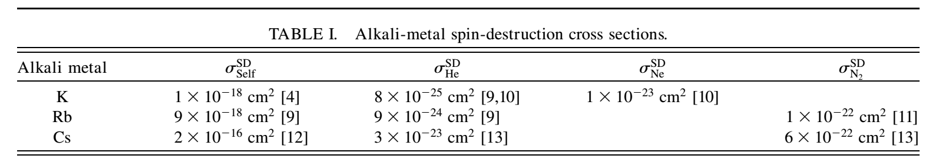

**"Radiation trapping in rubidium optical pumping at low buffer-gas pressures"**

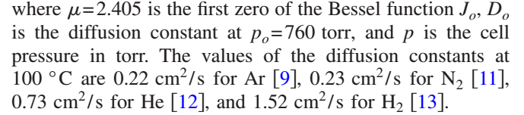

**"Rubidium Spin Relaxation in the Rare Gases Under Ultraclean Conditions"**

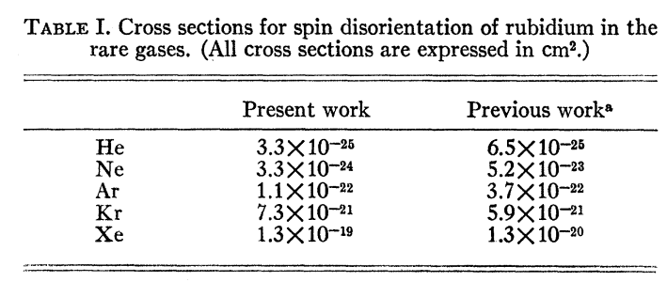

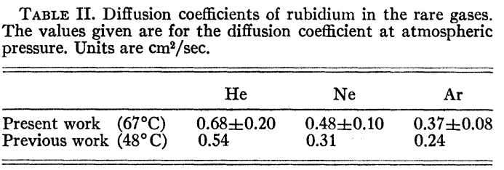

**Relaxation and frequency shifts in the ground state of Rb85**

